PCA Concepts and Cereals Dataset

1. Explain the PCA in steps 2
Example 2
2. Types of data 5
3. PCA in R 6
3.1. Use principal function from psych 6
3.2. Use princomp() & prcomp() function from stats package 6
3.3. Understand the output of R if using princomp() function 8
4. Select components 10
4.1. Eigenvalue criterion 11
4.2. Proportion of Variance Explain 11
4.3. Scree plot 11
5. Report Outcomes of PCA 12
6. Run the dataset using other function 13

This document is adopted from various online sources. Some sources are still live but some do not. Hence, if you do find the sources, please share with me.

Explain the PCA in steps

PCA aims to transform the dataset by finding its eigenvalues and eigenvectors. There are 2 ways to compute eigenvectors:
- Singular Value Decomposition (SVD)
- Eigenvalue decomposition or Spectrum decomposition of centred covariance matrix of data.

The whole process of obtaining principle components from a raw dataset can be simplified in six steps if using the second method:

- Take the whole dataset and consider variables that needs to run PCA.
- Compute the mean for every dimension of the whole dataset.
- Compute the covariance matrix of the whole dataset.
- Compute eigenvectors and the corresponding eigenvalues.
- Sort the eigenvectors by decreasing eigenvalues and choose k eigenvectors with the largest eigenvalues to form a d × k dimensional matrix W.
- Use this d × k eigenvector matrix to transform the samples onto the new subspace.

Example

Let our data matrix X be the score of five students:

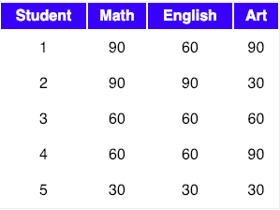

- Step 1: Consider variables to run PCA

We are left with a three-dimensional dataset. The data from the above table can be represented in matrix A

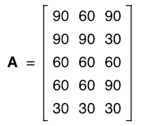

- Step 2: Compute the mean of every dimension of the whole dataset

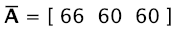

- Step 3: Compute the variance-covariance matrix

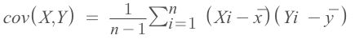

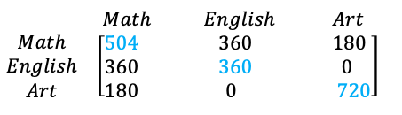

Shown in Blue along the diagonal, we see the variance of scores for each test. The art test has the biggest variance (720); and the English test, the smallest (360). Now we can say that art test scores have more variability than English test scores.

The covariance is displayed in black in the off-diagonal elements of the matrix A:

- The covariance between math and English is positive (360), and the covariance between math and art is positive (180). This means the scores tend to covary in a positive way. As scores on math go up, scores on art and English also tend to go up; and vice versa.
- The covariance between English and art, however, is zero. This means there tends to be no predictable relationship between the movement of English and art scores.

Step 4: Compute eigenvectors and eigenvalues

Let A be a square matrix, ν a vector and λ a scalar that satisfies Aν = λν, then λ is called eigenvalue associated with eigenvector ν of A. The eigenvalues of A are roots of the characteristic equation

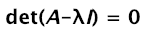

Calculating det(A-λI) first, I is an identity matrix

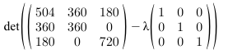

Simplifying the matrix first, we can calculate the determinant later

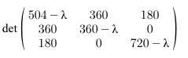

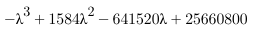

After solving this equation for the value of λ, we get the following value:

Step 5: Sort the eigenvectors by decreasing eigenvalues and choose k eigenvectors with the largest eigenvalues to form a d × k dimensional matrix W

We started with the goal to reduce the dimensionality of our feature space, i.e., projecting the feature space via PCA onto a smaller subspace, where the eigenvectors will form the axes of this new feature subspace. However, the eigenvectors only define the directions of the new axis, since they have all the same unit length 1.

So, in order to decide which eigenvector(s) we want to drop for our lower-dimensional subspace, we have to take a look at the corresponding eigenvalues of the eigenvectors. Roughly speaking, the eigenvectors with the lowest eigenvalues bear the least information about the distribution of the data, and those are the ones we want to drop.

The common approach is to rank the eigenvectors from highest to lowest corresponding eigenvalue and choose the top k eigenvectors.

So, after sorting the eigenvalues in decreasing order, we have

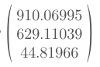

Eigenvectors corresponding to two maximum eigenvalues

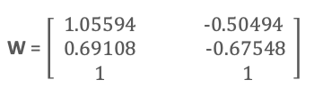

Step 6: Transform the samples onto the new subspace

We use the 2×3 dimensional matrix W that we just computed to transform our samples onto the new subspace via the equation y = W′ × x where W′ is the transpose of the matrix W.

Types of data

PCA finds and eliminate less informative (duplicate) information on feature set and reduce the dimension of feature space. In other words, imagine a N-dimensional hyperspace, PCA finds such M (M < N) features that the data variates most. In this way data may be represented as M-dimensional feature vectors. Mathematically, it is some-kind of a eigen-values & eigen vectors calculation of a feature space.

PCA is designed for continuous variables. It tries to minimize variance (=squared deviations). The concept of squared deviations can break down when you have binary variables. This means that PCA can work on categorical data that does not mean that it will work very well. So this means that it depends on application and types of problems.

PCA in R

Use principal function from psych

﻿principal(r, nfactors = 1, residuals = FALSE, rotate="varimax", n.obs=NA, scores=TRUE)

Note that this function calculates PCA from correlation matrix and therefore, there is no need to normalise data.

Arguments | Explanation
r | ﻿a correlation matrix. If a raw data matrix is used, the correlations will be found using pairwise deletions for missing values.
nfactors | ﻿Number of components to extract
residuals | ﻿FALSE, do not show residuals, TRUE, report residuals  The column labeled h2 contains the component communalities—the amount of  variance in each variable explained by the components.  The u2 column contains the component uniquenesses—the amount of variance not accounted for by the components  (or 1 – h2).  Note: no need to use this argument
Rotate | Varimax
n.obs | Missing values
scores

Note: Because PCA is performed on a correlation matrix, the raw data is automatically
converted to a correlation matrix before the components are extracted

Use princomp() & prcomp() function from stats package

prcomp() | princomp()  princomp(x, cor = TRUE, scores = TRUE)  x: numeric matrix or dataframe  cor: use correlation instead of covariance  scores: scores/projection of the data on principal components are produced
The prcomp() function is a numerically stable routine that returns a “prcomp object” that contains the square-root of the eigenvalues (“sdev”), the eigenvectors (“rotation”), and the scores. And so the preferred method is prcomp(). | The princomp() function is slightly less stable, but has more features. It returns a “princomp object” that contains the square-root of the eigenvalues (“sdev”), the eigenvectors (“loadings”), the means for each variable (“center”) and the scores (“scores”), as well as some other things.  Typing summary(princomp) or summary(prcomp) will return the percent of variation explained.
The prcomp() function will perform singular value decomposition of the covariance matrix | The princomp() function performing eigen decomposition of the correlation matrix. Sometime this one is called spectral decomposition
The singular value decomposition method is the preferred analysis for numerical accuracy
prcomp(datadf, scale = TRUE) | princomp(datadf, cor = TRUE)

Output of 2 functions:

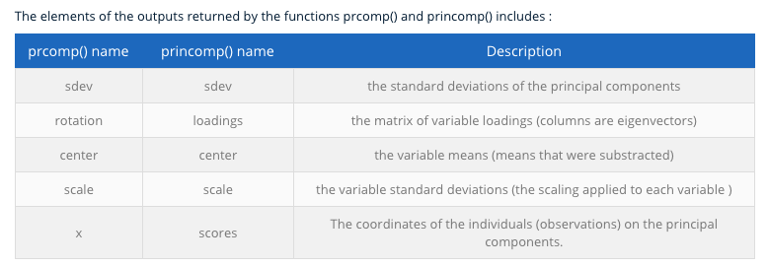

Note: there might be a different result between principal from psych and prcomp from stats if using $rotation and $loadings. This is because with psych, its vector doesn't have unit length. The prcomp vector has length 1. Loadings in psych are not unit eigenvectors because it uses them for factor rotation. So better to use prcomp() function.

Understand the output of R if using princomp() function

Summary()

Note using co-ordinate dataset with 2 variables.

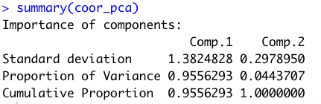

The purpose of PCA is to maximizes the variance of the projection to one dimension, after the data has been projected to orthogonal space to the previously selected components. So the standard deviation reports variances of PCs, which are eigenvalues of the covariance matrix. Note that mathematically standard deviations are singular values of the centered data matrix.

Reporting on loadings

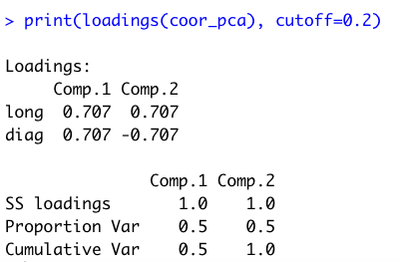

Loadings:
Comp.1 and Comp.2 are here called loadings. Loadings are the covariances/correlations between the original variables and the unit-scaled components. These loadings are the inverse In other words, loadings are simply coefficients of principal components, which equals to c eigenvectors.

In the PCA analysis, negative values of loadings of variable in the components of the PCA means the existence of an inverse correlation between the factor PCA and the variables.

Double check by using eigen() function.

SS loadings: always is 1.
Loading plots

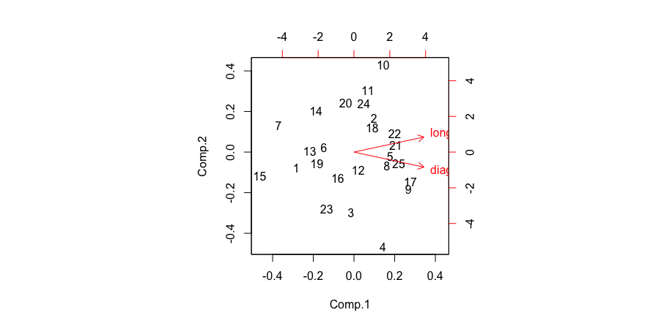

The plot above show PC scores of samples (numbers) and loadings of variables. This plot also hints at how variables correlate with one another: a small angle implies positive correlation, a large one suggests negative correlation, and a 90° angle indicates no correlation between two characteristics.

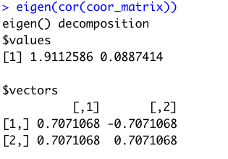

Select components

There are three common approaches in helping to make this decision:
Note that to demonstrate the criteria, cities dataset is used along with Rcode

- Eigenvalue criterion
- Proportion of variance explained criterion
- Scree plot criterion

Eigenvalue criterion
The sum of the eigenvalues is equal to the number of variables entered into the PCA; however, the eigenvalues will range from greater than one to near zero. An eigenvalue of 1 means that the principal component would explain about one variable’s worth of the variability. The rationale for using the eigenvalue criterion is that each component should explain at least one variable’s worth of the variability, and therefore, the eigenvalue criterion states that only components with eigenvalues greater than 1 should be retained.

Based on the cities dataset, R output gives 3 PCs with eigenvalues larger than 1.

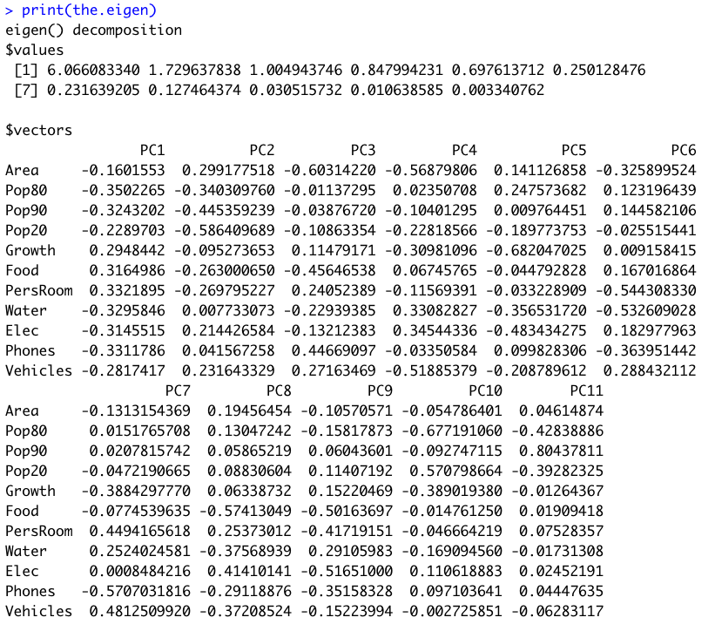

Proportion of Variance Explain

Using summary() function, look at the cumulative percentage and decide as how many PCs you want to select.

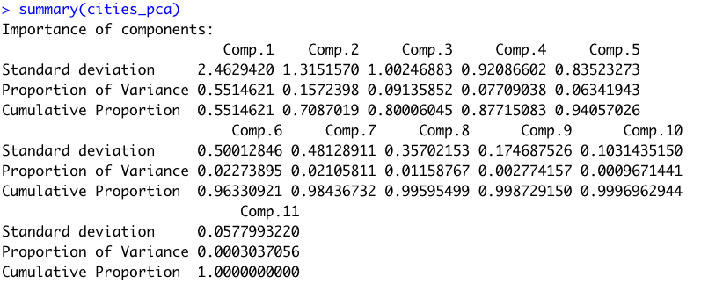

Many experts suggest to select the total number of components that can explain 80% of total variance.

Scree plot

This plot populates the variances against the number of the principal component.

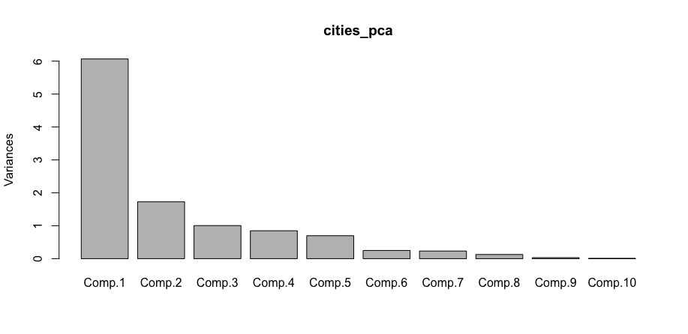

The variances of components are actually the eigen values.

Report Outcomes of PCA

2 main items that are needed to report the results of PCA:
- Numbers of PCs
- Variables that loads on each component

Based on all criteria, we decided that 3 PCs are the best choice.

Using Multicollinearity is a way to help to decide as what variables should be in a component.

Food, PersRoom, Elec, Water and Phone – all have VIF values are larger than 5.

Also using the loadings to decide.

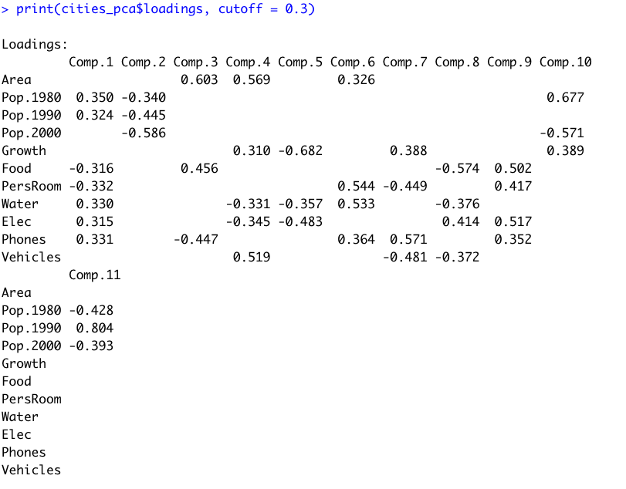

Component one (Comp.1): Looks like PersRoom, Water, and Phone can be part of Comp.1
Component two (Comp.2): Population in 3 years can part of
Component three (Comp.3): Area and Food.

Run the dataset using other function

Compare if using rotation is better.

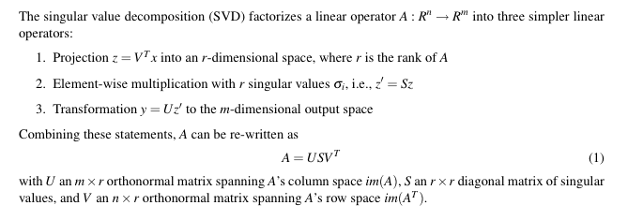
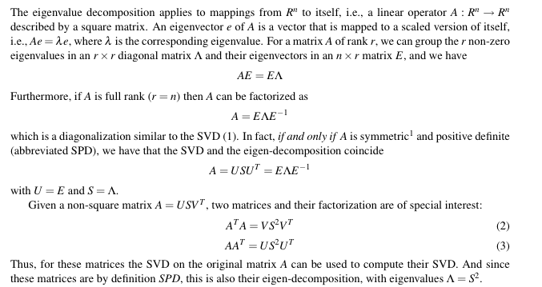
Eigenvector is just a coefficient of orthogonal transformation or projection, it is devoid of "load" within its value. "Load" is (information of the amount of) variance, magnitude. PCs are extracted to explain variance of the variables. Eigenvalues are the variances of (= explained by) PCs.
PCA-Large-Dataset.R

